**COMP 3710 Applied Artificial Intelligence**

Winter 2019

**Final Exam – 2 Hours**

Student Name: Student Number:

1. (2 marks) Define the formal representation of a state in the CSP searching for n-queens problem.
2. Data structure

A linear of n elements

1. Domain or domains

The domain for the each element in the above array is {-1, 0, …, n-1}, where -1 represents “empty”.

1. (2 marks) Define the formal representation of an individual in the genetic algorithm for n-queens problem.
2. Data structure

A linear of n elements

1. Domain or domains

The domain for the each element in the above array is {-1, 0, …, n-1}

1. (4 marks) A Bayesian network is given as follows:

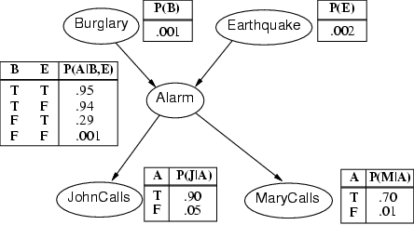

Compute the probability that John calls, Mary does not call, Alarm isn’t ringing, and there is no Burglary. You should show how to compute the probability. The final answer should be an expression of additions and multiplications of numbers.

P(J, ~M, ~A, ~B) = P(J, ~M, ~A, ~B, E) + P(J, ~M, ~A, ~B, ~E)

= p(j|~a) p(~m|~a) p(~a|~b,e) p(~b) p(e) + p(j|~a) p(~m|~a) p(~a|~b,~e) p(~b) p(~e)

= 0.05 * (1 – 0.01) * (1 – 0.29) * (1 – 0.001) * 0.002 +

0.05 * (1 – 0.01) * (1 – 0.001) * (1 – 0.001) * (1 – 0.002)

1. (5 marks) There are two output nodes in a backpropagation neural networks. The two output nodes are connected to two hidden nodes.

* Weights between the hidden layer and the output layer are 0.3, 0.6, 0.7, and 0.4.
* The outputs from the hidden nodes are 1 and 0.
* The outputs from the output nodes are 0.4 and 0.2. (The values may not be accurate. You can just use them for this question.)
* The expected outputs are 1 and 1.
* The learning rate is α = 0.1.
* The formulas are δ*k* = *yk* (1 – *yk*) *ek*; *wjk* = *wjk* + α *yj* δ*k*

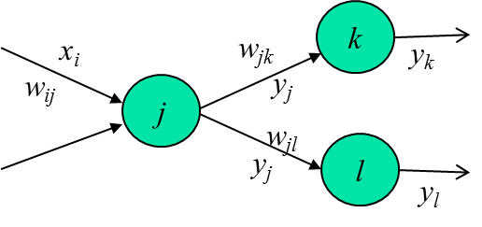

1. (1 mark) Draw a diagram showing two layers, outputs, and weights, with the above values.

1

0

0.4

0.2

0.3

0.6

0.7

0.4

1. (2 marks) Compute the deltas for the output nodes.

E0 = 1 – 0.4 = 0.6

E1 = 1 – 0.2 = 0.8

d0 = 0.4 (1 – 0.4) 0.6

d1 = 0.2 (1 – 0.2) 0.8

1. (2 marks) Compute the new weights between the hidden layer and the output layer.

w00 = 0.3 + 0.1 * 1 * d0

w01 = 0.6 + 0.1 * 1 * d1

w10 = 0.7 + 0.1 * 0 * d0

w11 = 0.4 + 0.1 * 0 * d1

1. (3 marks) Find *P*(¬*toothache* | (¬*cavity* ∨ *catch*)) from the next ***joint probability distribution***.

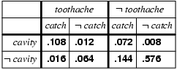

(.072 + .144 + .576) / (.108 + .016 + .072 + .144 + .576)

1. (4 marks) Consider naïve Bayes classifier with the following training data set. What is the classification for (*Medium*, *Medium*, *Large*)?

|  |  |  |  |  |
| --- | --- | --- | --- | --- |
| *X* | *d*1 | *d*2 | *d*3 | **Class** |
| **x**1 | *Medium* | *Large* | *Medium* | *A* |
| **x**2 | *XLarge* | *Small* | *XLarge* | *B* |
| **x**3 | *Small* | *Large* | *Medium* | *A* |
| **x**4 | *Medium* | *XLarge* | *Large* | *A* |
| **x**5 | *XLarge* | *Medium* | *XLarge* | *B* |
| **x**6 | *Medium* | *Small* | *Large* | *C* |
| **x**7 | *Small* | *Medium* | *XLarge* | *A* |
| **x**8 | *Medium* | *Large* | *Large* | *B* |
| **x**9 | *Medium* | *Medium* | *XLarge* | *A* |
| **x**10 | *Large* | *Large* | *Large* | *C* |
| **x**11 | *Large* | *Medium* | *Small* | *A* |
| **x**12 | *Small* | *Medium* | *Small* | *B* |
| **x**13 | *Medium* | *Small* | *XLarge* | *A* |
| **x**14 | *XLarge* | *Large* | *XLarge* | *C* |
| **x**15 | *Medium* | *Medium* | *XLarge* | *A* |

P(A) P(M|A) P(M|A) P(L|A) = 8/15 * 5/8 * 4/8 * 1/8

P(B) P(M|B) P(M|B) P(L|B) = 4/15 * 1/4 * 2/4 * 1/4

P(A) P(M|C) P(M|C) P(L|C) = 3/15 * 1/3 * 0/3 * 2/3

* Class A

1. (4 marks) Consider the following fuzzy rules.

1

0

5

10

|  |  |  |  |  |  |
| --- | --- | --- | --- | --- | --- |
|  | *Theta* | | | | |
| *dTheta* |  | NM | NS | ZE | PS |
| NM |  |  | **PM** |  |
| NS |  |  | **PM** | **PS** |
| ZE | **PM** | **PS** | **PS** | **ZE** |
| PS |  | **ZE** | **NS** | **NS** |
| PM |  |  | **NM** |  |

1. (2 marks) Fuzzification: Let’s assume that PS is defined as the above triangle shape membership, (0, 5, 10), function over [0, 20]. Decide the PS membership value for the input value 7.

(10 – 7) / (10 – 5) = 0.6

1. (2 marks) Inference: Let’s assume the input for *Theta* is fuzzified to PS:0.2 and ZE:0.7. Let’s assume the input for *dTheta* is fuzzified to ZE:0.8 and NS:0.6. Find the output fuzzy sets with their membership values.

ZE:0.7 and NS:0.6 -> PM:0.6

ZE:0.7 and ZE:0.8 -> PS:0.7

PS:0.2 and NS:0.6 -> PS:0.2

PS:0.2 and ZE:0.8 -> ZE:0.2

* PM:0.6, PS:0.7, ZE:0.2

1. (2 marks) Explain an issue in k-means and fuzzy c-means clustering algorithms.

How to decide the proper number of clusters?